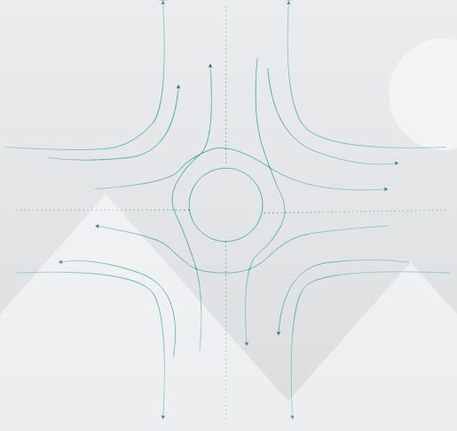

* Based on the assumption that the intersection has a one-lane flow and that two roads meet at a perpendicular intersection, the system above is designed accordingly. In light of that, the intersection is expected to have a medium traffic flow.
* The circle at the centre represents a solid object that must be passed through by the driver.
* We can install security cameras, speed cameras, traffic signals, and traffic controller booths in the circle, so it will all be safe from accidents
* It is possible to create a separate path for bicycles and pedestrians. There can be an established bus stop 100 meters from the intersection so that no intersection will occur.
* The number of accidents is reduced by three times with this system. Normally, intersections will have 24 points of intersection as shown below.

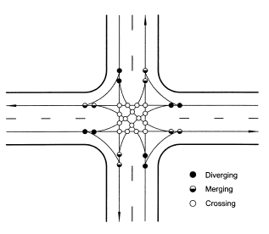

* Through the design, the 24 points are reduced to 8, thus reducing the likelihood of accidents occurring.
* If the accident happens, the impact will not be at a straight line, but will be at an inclination angle, which can save lives.
* The curve may also reduce the speed of the vehicle, reducing the chances of a serious impact.
* Other modifications may be made in the future, such as designing an underpass for pedestrians, or giving separate lanes for bikes, cars, and cyclists.
* At the same time the roads will have to be expanded, a flyover system or cloverleaf intersection system can be implemented to avoid most traffic jams and accidents